Task 1: Designated time 30 minutes

Scary Place

What is the scariest place you can imagine? For some people, it might be a neglected house that seems haunted by its former residents. For others, it might be a dark basement, covered with cobwebs and possibly harbouring rats and spiders. Think about it. What kinds of sights and sounds seem especially scary to you?

1. DESCRIPTIVE WRITING

Describe each of the following places in a way that will scare your reader. Make sure that you write at least five sentences to describe the places in detail so as to scare your readers.

1. a very old, broken-down cottage:

The old cottage on the side of the road is known to have evil spirits living within it. Legend says that the broken windows, the tore-down walls and other things were the resultant from the war of the immortals that took place there. The lights don’t seem to functioning there and the last family, who went there, never came back. The creaking of the doors symbolizes cruelty and the nights there are dead still.

1. a cemetery at night:

The cemetery is one of the darkest places in history, this is where the dead body’s spirits crawl out from their grave and look for people to join them in their fate. These spirits are known to spike at night time and they hunt for blood. As every night goes past, you can almost sense them sitting right next to you!

1. a dark attic or basement:

People often ignore the basement and the attic of a house and store all their goods there, so it is a perfect opportunity for a spirit or a ghost to attack you from the basement or the attic. It is extremely dark there which means that they can spike at anytime from anywhere. Legend says that the ghost families go out of the attics and basements at night while humans are sleeping and kill them while in their sleep. These creatures are hidden; they might be right next to you this instant.

1. a military battlefield:

A military battlefield is almost the perfect place for some gothic activities to take place, these bases are fully equipped with weaponry and armoury and at night, people can take you by surprise. The wind rustles by and you can hear the reloading of the gun…

1. in the path of a hurricane:

When you are standing in a path of a hurricane and sitting in you comfortable house, you can feel your heart bouncing out of your chest, you can feel that one drop of cold sweat drip from your eye and you can see your spirit leaving your body as the hurricane comes closer. It is almost as if you know you are going to die a painful death and there is nothing you can do because you are paralyzed by this thought…

______________________________________________________________________________________

Task 2: Designated time 30 minutes

1. DESCRIPTIVE WRITING.

Choose one of the situations listed in this box and imagine that you had a very frightening experience there.

Create a mind-map for a gothic/ scary story, which includes any one of the situations mentioned below, with a proper beginning, climax, resolution and conflict.

Please note you will create a mind map, not write a story.

|  |
| --- |
| on a deserted island  at a zoo when an animal escapes  in a building that is on fire  in a boat during a storm at sea  **in a bank during a robbery**  skating on thin ice when it cracks  in a car when the brakes fail  on a stage when you have stage fright |

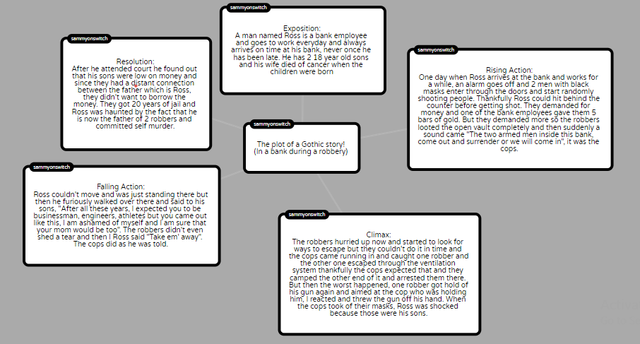

Task 3 Designated time 60 minutes

Compose a story of 250-350 words choosing any one of the following prompts. Your story must reach up to the climax and end on a cliff hanger only. This means that you write about the setting, the characters, rising action and end at the point of highest tension i.e. the climax.

**A man wakes up with no face- no eyes, no nose, no mouth. Just smooth skin.**

OR

**A monster is terrified by the scary child who lives above his bed.**

**Please note: You must not write an entire story. The action reaches the climax only and is a cliff-hanger.**

**It was the summer of 2020, everyone in the world was facing the virus called COVID-19 and there was almost no hope for a cure anytime soon. A man named James was an employee who lost his job due to this pandemic and one bad habit he developed through the quarantine was he slept a lot, maybe 15 hours a day! One fine day he woke up at 1 in the afternoon and he was pouring himself and his 2 children some milk and cereal for breakfast. They weren’t very rich and James’s wife passed away due to a car accident. After eating breakfast, he went to watch some TV and saw the news, the cases just passed 1 million in the whole world and he as usual, didn’t care. He went to sleep on the couch and after what seemed to be like 30 minutes after he fell asleep, his children screamed, “Ahhhhh, there is a man who has no eyes and nose and mouth!”, James rushed to his children’s room and saw a middle aged man with none of his 5 sensory organs. He told his children to move away and they called the cops. The cops came and they didn’t know what to do and told them to take some precautions. Since he couldn’t go outside and couldn’t go anywhere, he of course fell asleep with his children, he was dreaming about himself with his wife but sadly he woke up right after. There was one thing unusual though, he couldn’t see, he went to rub his eye but when he touched at that are, there was nothing there! He scanned his entire face and his sensory organs weren’t there…**